THE PRESIDENT’S OFFICE
REGIONAL ADMINISTRATION AND LOCAL GOVERNMENT
FORM TWO JOINT EXAMINATION FOR GOVERNMENT SCHOOLS – JEGOS
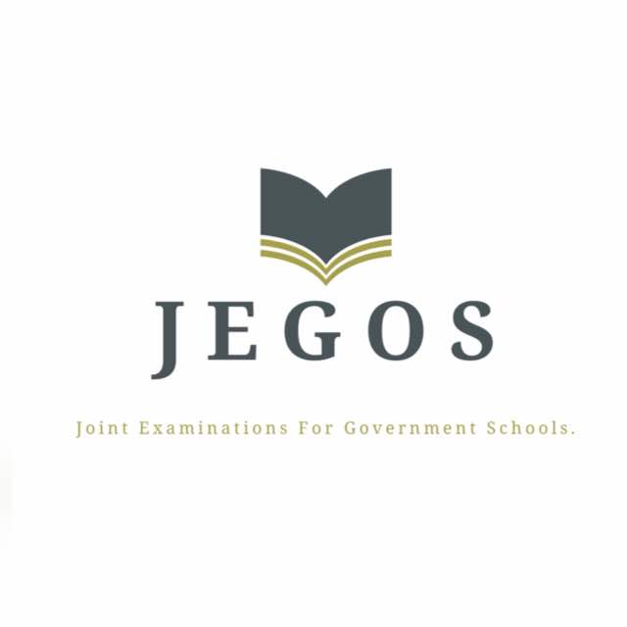

PRE-MOCK EXAMINATION
011 CIVICS
MARKING SCHEME 2024

SECTION A (15 marks)
- Answers

Question
Answer | C | C | D | A | C | A | D | D | A | C

- Answers

List A
List B | C | D | A | B | F

SECTION B (70 marks)
Answer all questions in this section

- Standing still when singing the national anthem or rising the national flag
- Honoring and obeying the national constitution
- Avoiding deliberately producing or destroying of national currency
- Attending and participating in national festivals
- Proper using of national language.

- Courtship laid a foundation for love and affection before and after marriage.
- Courtship enable partners to know each other before marriage, which simplify conflict resolution after marriage.
- Courtship enables partners to make preparations for marriage.
- Courtship influences behavior change before marriage.
- Courtship enables partners to plan for family life after marriage

- Observation
- Interview;
- Questionnaire;
- Mass media;
- Documentary review

- Constitutional amendment of 1984 led to the introduction of bill of rights
- Constitutional amendment of 1992 led to the introduction of multiparty system
- Constitutional amendment of 1984 led to the introduction of periodic rule for the president
- Constitution amendment of 1992 and 2000 led to women empowerment and promoting gender equality
- Constitution amendment of 2000 led to the broadening of rule of law.

- It leads to increase of risky behaviours. Eg unsafe sex, excessive use of alcohol and
- It leads to early pregnancy
- Involvement in social crimes. Eg raping, drug abuse and robbery
- It leads to laziness and refraining from work
- Distancing from family members and good friends
- Increase of depression and anxiety(extra)

- Making of arbitrary and oppressive laws
- Use of coersive organs to torture citizens
- Discriminating citizens
- Not practicing rule of law
- Not including a bill of rights
Any other relevant point

- Provision of road safety education. Eg road safety week
- Governing and monitoring the speed of vehicles. Eg use of speed governor and traffic speed radar
- Constructing and maintaining of good infrastructures
- Enactment and enforcement of laws
- The use of traffic officers.
- Placing of roads signs ( extra)
Any other relevant points

SECTION C (15 marks)

Introduction (1.5 marks)
Meaning of separation of power or democracy
Main Body ( 6 points @2 marks) total 12 marks
Reasons for separation of power are as follows
- To reduce or eliminate corruption
- To promote accountability and transparency
- To promote check and balance and prevent misuse of power
- It increase and simplify service provision
- It leads to smooth and effective operation of the government
- It promote rule of law; for example through independent judicial system
Any other relevant points
Conclusion (1.5 marks )
Any relevant conclusion.

